Final Project Report

COVID-19 Vaccine Management System



Project Supervisor
Hina Ishaq

Submitted By

S2102A3CF0

Hamza Ashraf BS170400637

Software Projects & Research Section,
Department of Computer Sciences,
Virtual University of Pakistan


CERTIFICATE

This is to certify that Hamza Ashraf (BS170400637) has worked on and completed his Software Project at Software & Research Projects Section, Department of Computer Sciences, Virtual University of Pakistan in partial fulfillment of the requirement for the degree of BS in Computer Sciences under my guidance and supervision.

In our opinion, it is satisfactory and up to the mark and therefore fulfills the requirements of BS in Computer Sciences.

Supervisor / Internal Examiner

Hina Ishaq
Supervisor,
Software Projects & Research Section,
Department of Computer Sciences
Virtual University of Pakistan

___________________
(Signature)

External Examiner/Subject Specialist
<<External Supervisor Name>>

___________________
(Signature)

Accepted By:

_____________
(For office use)

EXORDIUM

In the name of Allah, the Compassionate, the Merciful.

Praise be to Allah, Lord of Creation,
The Compassionate, the Merciful,
King of Judgment-day!

You alone we worship, and to You alone we pray for help,
Guide us to the straight path

The path of those who You have favored,

Not of those who have incurred Your wrath,
Nor of those who have gone astray.

DEDICATION

I dedicate my project work to my family and a couple of friends. A special feeling of gratitude to my loving parents, whose words of encouragement and push for tenacity ring in my ears. My sister has never left my side and is very special.
I also dedicate this dissertation to my many friends and fellow members from the Institute of Cost and Management Accountants of Pakistan (ICMAP), who have supported me throughout the process. I will always appreciate all they have done, especially Waseem Sarwar for helping me develop my consistency skills, Rashid Faiz for the many hours of proofreading, and Hamza Anwar for helping me to master the leader dots.
I dedicate this work and give special thanks to my best friend Haris Shahid and my mother for being there for me throughout the entire graduation program. Both of you have been my best cheerleaders.

ACKNOWLEDGEMENT

This work would not have been possible without the financial support of my family. I am especially indebted to my sister and brother who have been supportive of my career goals and who worked actively to provide me with the protected academic time to pursue those goals.
I am grateful to all of those with whom I have had the pleasure to work during this and other similar projects. Each of the members of the Institute of Cost and Management Accountants of Pakistan (ICMAP) has provided me extensive personal and professional guidance and taught me a great deal about both financial management and life in general.
I would especially like to thank Mr. M Iqbal Ghori, the president of the institute. As my teacher and mentor, he has taught me more than I could ever give him credit for here. He has shown me, by his example, what a good strategic planner (and person) should be.
PREFACE

This basis for this project originally stemmed from my passion for developing
dynamic web applications with big data and analytics. As of now, the world has been surfing the COVID-19 pandemic, having troubles in getting themselves vaccinated, there will be a greater need to schedule appointment for vaccination using an online portal. How will we schedule an appointment for vaccination? It is my passion to not only find out, but to develop tools to break down barriers of accessibility for future generations.
In truth, I could not have achieved my current level of success without a strong
support group. First of all, my parents, who supported me with love and understanding.
And secondly, my institute members, each of whom has provided patient advice and
guidance throughout the academics. Thank you all for your unwavering support.
TABLE OF CONTENTS

CHAPTER NO. 1
gathering & Analyzing info 10

1.1 Introduction

1.2 purpose

1.3 scope

1.4 definitions, acronyms and abbreviations

1.5 Project requirements

1.5.1 Functional Requirements

1.5.2 Non-Functional Requirements

1.6 use cases and usage scenarios

1.6.1 Use Case Diagrams

1.6.2 Usage Scenarios

1.7 Development Methodology

1.7.1 Chosen Methodology

1.7.2 Reasons for Chosen Methodology
1.7.3 Work Plan (Gantt Chart)
1.7.4 Project Schedule (Submission Calendar)

CHAPTER NO. 2
designing the project 25

2.1 Introduction

2.2 purpose

2.3 scope

2.4 definitions, acronyms and abbreviations

2.5 Architectural Representation (Architecture Diagram)

2.6 Dynamic Model: Sequence Diagrams

2.7 Object Model/Logical Model: Class Diagram

2.8 Database Model (Database Diagram)

2.9 Graphical User Interfaces

Chapter no.3
DEvelopment 33
3.1 Development plan (Architecture Diagram)

CHAPTER 1
Gathering & Analyzing Info

1.1 Introduction
“COVID-19 Vaccine Management System” is an appointment scheduling system to facilitate the residents with scheduling their COVID-19 vaccine appointments. It will provide on hand information about current COVID-19 situation. The aim of this website is to manage mass vaccination, including vaccine distribution and administration. The system will be designed to provide real- time access to vaccine distribution centers. The system will also reduce the manual efforts and cost required for paper work. So, it will benefit the both public and government.

1.2 Purpose
As of now, the whole world has suffered heavily and is still suffering from COVID-19 virus which has turned this world in a pandemic situation. There is a need to educate people of the symptoms, severity, causes of spreading this virus, so that can protect themselves and their loved ones. People are finding it difficult to get themselves vaccinated. There is a need to develop a centralized system to manage scheduling mass vaccination and resolving queries from public using modern communication channels i.e., Internet.

1.3 Scope
This system will contain the information regarding COVID-19 virus and how it spreads and it will also provide preventive measure that individuals can take in their homes and workplaces. Said system will provide complete details of COVID-19 cases including active cases, recovered, critical. These cases will be sub-divided on regional basis and filters can be applied to analyze cases data to manage vaccines distribution properly.
Patients can visit this website on any gadgets which supports a web browser. Patients can either sign up through this website or can schedule their appointment to get vaccinated after registration. In both cases an appointment will be schedule and their specified vaccination center and time slot will be locked. So, that they do not have any troubles while getting vaccinated.
There will be specific dashboards available for users and admins through which they can interact with the system. Admins can schedule appointments of patients, add new user/admins, accept or reject appointment of a patient, add vaccination centers, add available time slots and update information being shown on website regarding cases. Admins will also have access to data of patients vaccinated.
This system will also contain information about vaccines available in the market and provide comprehensive comparison of these by mentioning their pros and cons.

1.4 Definitions, Acronyms and Abbreviations
- URL
Uniform Resource Locator

1.5 Project requirements

1.5.1 Functional Requirements
Functional requirements of the system include followings:
- Users can view the details of vaccination, vaccination procedures and related information without registration.
- Users can register themselves to get appointments.
- Users can schedule appointments online.
- Users can also give feedback about the services provided.
- User can also register complaint about any suspicious activity or any misconduct.
- Registration and Login interface of the main administrator.
- The main administrator can add any other person as admin.
- Admin can add/remove categories or edit existing categories.
- Admin can insert, delete, view and update records.
- Admin can accept or reject the appointment and automatic email will be sent to user about the status.
- Logout interface to logout of system.

1.5.2 Non-Functional Requirements
This system has following non-functional requirements:
- Availability: The system should be designed by keeping the concepts of high availability. Because this system will be providing services to general public and system might breakdown if a lot of users connect at the same time. So, the system should always be online to provide core services.
- Performance: Application should be designed in such a way that it uses fewer computing resources so that it could be deployed in a cos-effective way.
- Usability: Interface should be clear and concise and everything should be categorized properly so that users can interact with the system without having to get any technical training.
- Security: As general public will be using this system and their login credentials will be saved in database. System should provide secure ways to interact with the system and passwords should also be stored in encrypted form so that, user’s privacy doesn’t compromise in any case.

1.6 Use Cases and Usage Scenarios

1.6.1 Use Case Diagrams
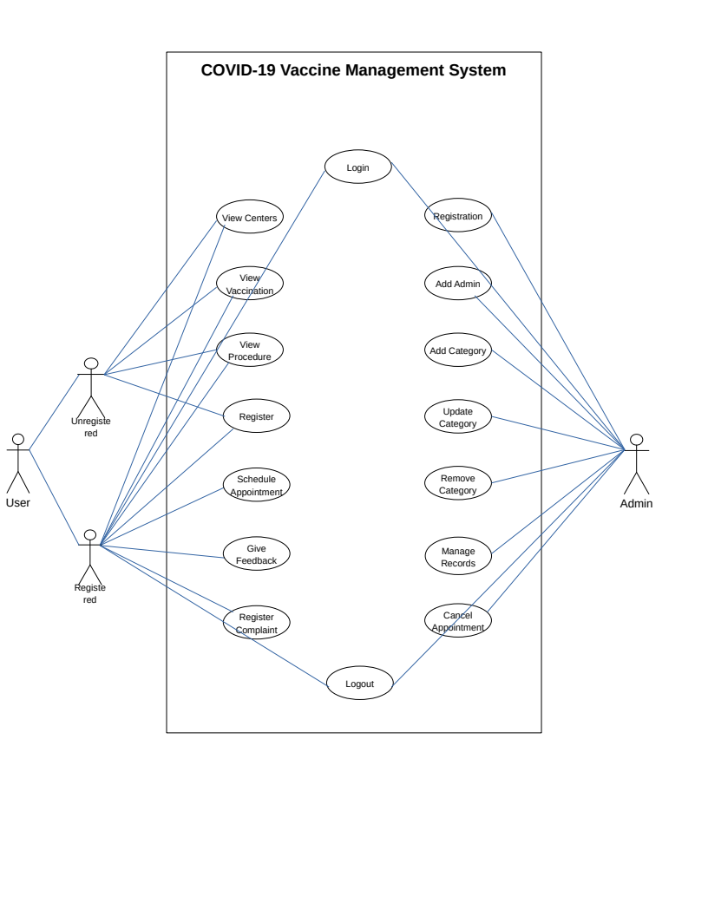

1.6.2 Usage Scenarios

Usage Scenario 1
Use Case Title | View Vaccination Centers
User Case Id | Case_001
Actions | - User types in the URL in the browser and get in to homepage  - User sees vaccination centers in navigation and clicks it  - Vaccination centers page opens with all the available vaccination centers  - User can apply filters by searching in the search filed and hit enter key i.e., city  - On applying filters vaccination centers with filter criteria will be shown  - User can click on a center to view details about center
Description | Check all available centers for COVID-19 vaccination
Alternative Paths | Scroll down and click a center to display detailed information
Preconditions | Web browser with a working internet connection
Post-conditions | User finds a suitable vaccination center
Author | Hamza Ashraf (BS170400637)
Exceptions | No centers available

Usage Scenario 2
Use Case Title | View Vaccination Types / Details
User Case Id | Case_002
Actions | - User types in the URL in the browser and gets to the homepage  - User sees vaccinations in navigation and clicks it  - Vaccinations page opens with all the available vaccinations  - User can click on a vaccination to view details about vaccination
Description | Check all available vaccinations of COVID-19
Alternative Paths | Scroll down and click a vaccination to display detailed information
Preconditions | Web browser with a working internet connection
Post-conditions | User finds required details about a vaccination
Author | Hamza Ashraf (BS170400637)
Exceptions | No vaccinations available

Usage Scenario 3
Use Case Title | View Procedure To Get Vaccinated
User Case Id | Case_003
Actions | - User types in the URL in the browser and get in to homepage  - User sees procedure in navigation and clicks it  - Vaccination procedure page opens with a list of procedures to get vaccinated
Description | Check procedure to get vaccination
Alternative Paths | User can get to this page from vaccination appointment page
Preconditions | Web browser with a working internet connection
Post-conditions | User finds complete procedure to get vaccinated
Author | Hamza Ashraf (BS170400637)
Exceptions | There can be a different procedure for physically challenged people

Usage Scenario 4
Use Case Title | User Registration
User Case Id | Case_004
Actions | - User types in the URL in the browser and get in to homepage  - User sees registration in navigation and clicks it  - Registration page opens with a registration form  - User types in details in input fields in the registration form and click register  - A success message is shown to user for registration and a link to login page is shown
Description | Get registered as a user
Alternative Paths | User clicks already registered login now to redirect to login page
Preconditions | Web browser with a working internet connection
Post-conditions | User gets registered
Author | Hamza Ashraf (BS170400637)
Exceptions | - Empty or invalid input values  - User already registered

Usage Scenario 5
Use Case Title | User Login
User Case Id | Case_005
Actions | - User types in the URL in the browser and get in to homepage  - User sees login in navigation and clicks it  - Login page opens with a login form  - User fill in the form and clicks login to login in to the system
Description | Login to the system to use restricted options
Alternative Paths | User can get to this page from sign up page
Preconditions | Web browser with a working internet connection
Post-conditions | User gets logged in to the system
Author | Hamza Ashraf (BS170400637)
Exceptions | Invalid credentials

Usage Scenario 6
Use Case Title | Schedule Appointment
User Case Id | Case_006
Actions | - User types in the URL in the browser and get in to homepage  - User login to the system  - User click Schedule an appointment and gets a page with appointment form  - User selects city, center, and vaccination type to make an appointment and clicks confirm
Description | Make an appointment to get vaccinated
Alternative Paths | Use can get to this page through dashboard
Preconditions | Web browser with a working internet connection
Post-conditions | User gets a successful appointment message
Author | Hamza Ashraf (BS170400637)
Exceptions | Appointment already scheduled

Usage Scenario 7
Use Case Title | Give Feedback
User Case Id | Case_007
Actions | - User types in the URL in the browser and get in to homepage  - User logins to the system and opens dashboard  - There is an option for feedback  - After clicking feedback option, a page with form will be shown  - User types in his message and submits feedback
Description | Give feedback of services after getting vaccinated
Alternative Paths | After scrolling down to footer user can open feedback form
Preconditions | - Web browser with a working internet connection  - Registered user and got vaccinated
Post-conditions | User submits its feedback for improvements
Author | Hamza Ashraf (BS170400637)
Exceptions | User is not registered

Usage Scenario 8
Use Case Title | Register a Complaint
User Case Id | Case_008
Actions | - User types in the URL in the browser and get in to homepage  - User logins to the system and opens dashboard  - There is an option to register a complaint  - On clicking register a complaint option a form is shown  - User selects appropriate values in fields and types in his message and submits his complaint
Description | Register a complaint about something wrong
Alternative Paths | After scrolling down to footer user can open complaint form
Preconditions | - Web browser with a working internet connection  - Registered user
Post-conditions | User submits its complaint for an action to be taken
Author | Hamza Ashraf (BS170400637)
Exceptions | User is not registered

Usage Scenario 9
Use Case Title | User Logout
User Case Id | Case_009
Actions | - User types in the URL in the browser and get in to homepage  - User logins to the system and after being logged in it can click on profile icon  - Profile icon will show an option to logout  - After clicking logout, a dialog with confirmation message will be shown  - After confirming user logout of the system
Description | User logout of the system and discontinue using services
Alternative Paths | Go to dashboard and click logout to terminate session
Preconditions | - Web browser with a working internet connection  - User already logged in
Post-conditions | User session is terminated and is no longer able to use services unless its logins again
Author | Hamza Ashraf (BS170400637)
Exceptions | User already logged out

Usage Scenario 10
Use Case Title | Administrator Registration
User Case Id | Case_010
Actions | - Admin logins to system as admin privileges  - Admin opens its dashboard and there is an option to manage administrators  - On clicking manage administrator admin can open an option to add administrator  - Admin needs to provide user name to make administrator  - On clicking add it will confirm password and administrator will be added in the system
Description | Add administrators of the system
Alternative Paths | Type in a specific URL to open a link to register as a administrator with a certain credentials to be provided
Preconditions | - Web browser with a working internet connection  - Logged in as a admin user
Post-conditions | Admin user is added
Author | Hamza Ashraf (BS170400637)
Exceptions | Already admin

Usage Scenario 11
Use Case Title | Approve / Reject An Appointment
User Case Id | Case_011
Actions | - Admin logins to the system with admin privileges  - After loading admin dashboard admin can view all appointments  - Admin can select any appointment from the list and can click approve or reject from dropdown and click proceed  - After clicking the button admin approval will be saved  - User will receive an email from server about appointment approval or rejection  - User can generate vaccination form
Description | Approve or reject appointment request of a user
Alternative Paths | Admin can view requests for appointments and it can accept or decline a request
Preconditions | - Web browser with a working internet connection  - Login as an admin user
Post-conditions | User appointment form can be generated
Author | Hamza Ashraf (BS170400637)
Exceptions | Appointment is already completed

Usage Scenario 12
Use Case Title | Manage Records
User Case Id | Case_012
Actions | - Admin logins to the system and opens dashboard  - Admin can open any link from navigation i.e. Vaccination centers, vaccination categories, cities, appointments  - Admin can view any data from these categories after clicking  - Admin can open any record from these categories and can click buttons to edit or delete any record
Description | Insert, update and delete records
Alternative Paths | Admin can find options to edit and delete records on their specific pages
Preconditions | - Web browser with a working internet connection  - Logged in as a admin
Post-conditions | Records get inserted, updated or deleted
Author | Hamza Ashraf (BS170400637)
Exceptions | Record not found

1.7 Development Methodology

1.7.1 Chosen Methodology
Some of the commonly used software development methodologies are listed below:
• Agile
• Lean
• Waterfall
• Iterative
• Spiral
• DevOps
There are a lot of software development methodologies available but for this project I will be using a combination of Waterfall and Spiral.

Waterfall methodology
Waterfall model is widely considered the oldest of the structured SDLC methodologies. It’s also a very straightforward approach: finish one phase, then move on to the next. Each stage relies on information from the previous stage and there is no going back. This model is also known as linear sequential model.
The waterfall model is a documentation-driven model. Therefore, it generates complete and comprehensive documentation and hence makes the maintenance task much easier. However, it suffers from facts that the client feedback is received when the product is deployed and any omission in the requirement specifications is not discovered until the product is shipped to the client after its completion. However, if requirements are already known this model is preferred for such system. As in our case we know our requirements of the project very clearly.

Spiral methodology
One of the most flexible SDLC methodologies, the Spiral model takes a cue from the Iterative model and its repetition; the project passes through four phases (planning, risk analysis, engineering and evaluation) over and over in a “spiral” until completed, allowing for multiple rounds of refinement.
The Spiral model is typically used for large projects. It enables development teams to build a highly customized product, and incorporate user feedback early on in the project. Another benefit of this SDLC model is risk management. Each iteration starts by looking ahead to potential risks, and figuring out how best to avoid or mitigate them.
Because our system is going to be used by general public and it is going to be refined over time so it is better for us to use a Spiral model. By implementing spiral, we can overcome the limitations like rigidity of Waterfall model, if it would have been used in isolation.

1.7.2 Reasons for Chosen Methodology
- We can follow project sequentially. i.e., from one stage to next.
- This model is easy to understand and use
- We will be getting specific product after each stage.
- By using combination of these two models, we can limit our risk of project failure.
- If at any stage, we need to add some additional functionalities, this model will make it possible.

1.7.3 Work Plan (Gantt Chart)

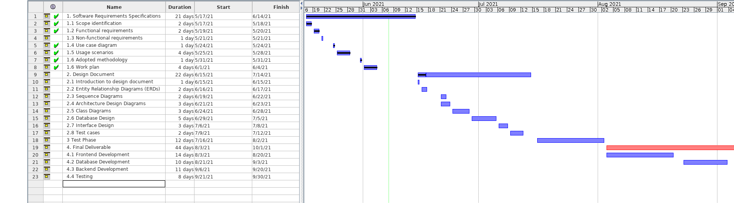

1.7.4 Project Schedule (Submission Calendar)

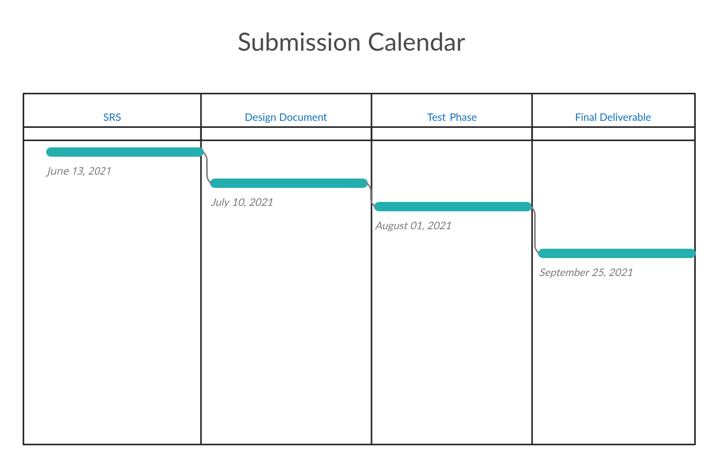

CHAPTER 2
Designing the Project

2.1 Introduction
Software Design Document is often referred as Software Design Specification. This document contains the detailed plan that is to be followed in order to design either a piece of software or a complex project. Software design document should contain the functionalities of end product in such a way that reader after reading this document can have a clear idea of what is going to be built. It is better to have a design document before jumping in to the coding phase.

2.2 Purpose
Having a well written design document could reduce any potential ambiguities in the system and its design. All stakeholders of the project including coders, testers, designers and end users can have same expectations from the system. Moreover, design document can streamline the coding phase as everything is pre-planned.

2.3 Scope
For this project titled “Covid-19 Vaccine Management System” design document contains followings:
- Entity Relationship Diagram (ERD)
- Sequence Diagrams
- Architecture Design Diagram
- Class Diagram
- Database Design
- Interface Design
- Test Cases

2.4 Definitions, Acronyms and Abbreviations
- UML
Unified Modeling Language

- DNS
Domain Name Server

- CDN
Content Delivery Network

2.5 Architectural Representation (Architecture Diagram)
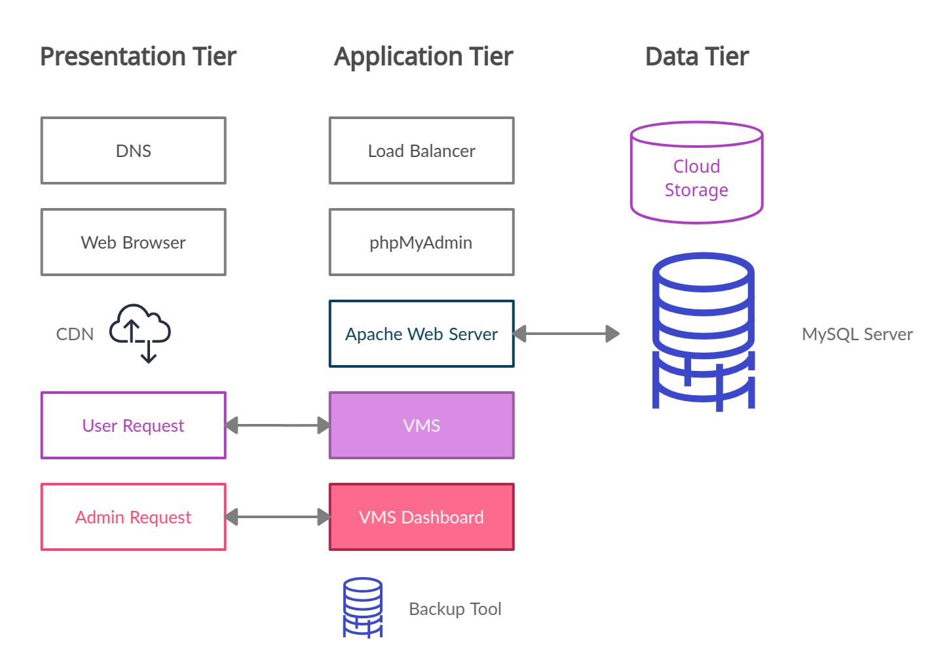

2.6 Dynamic Model (Sequence Diagrams)
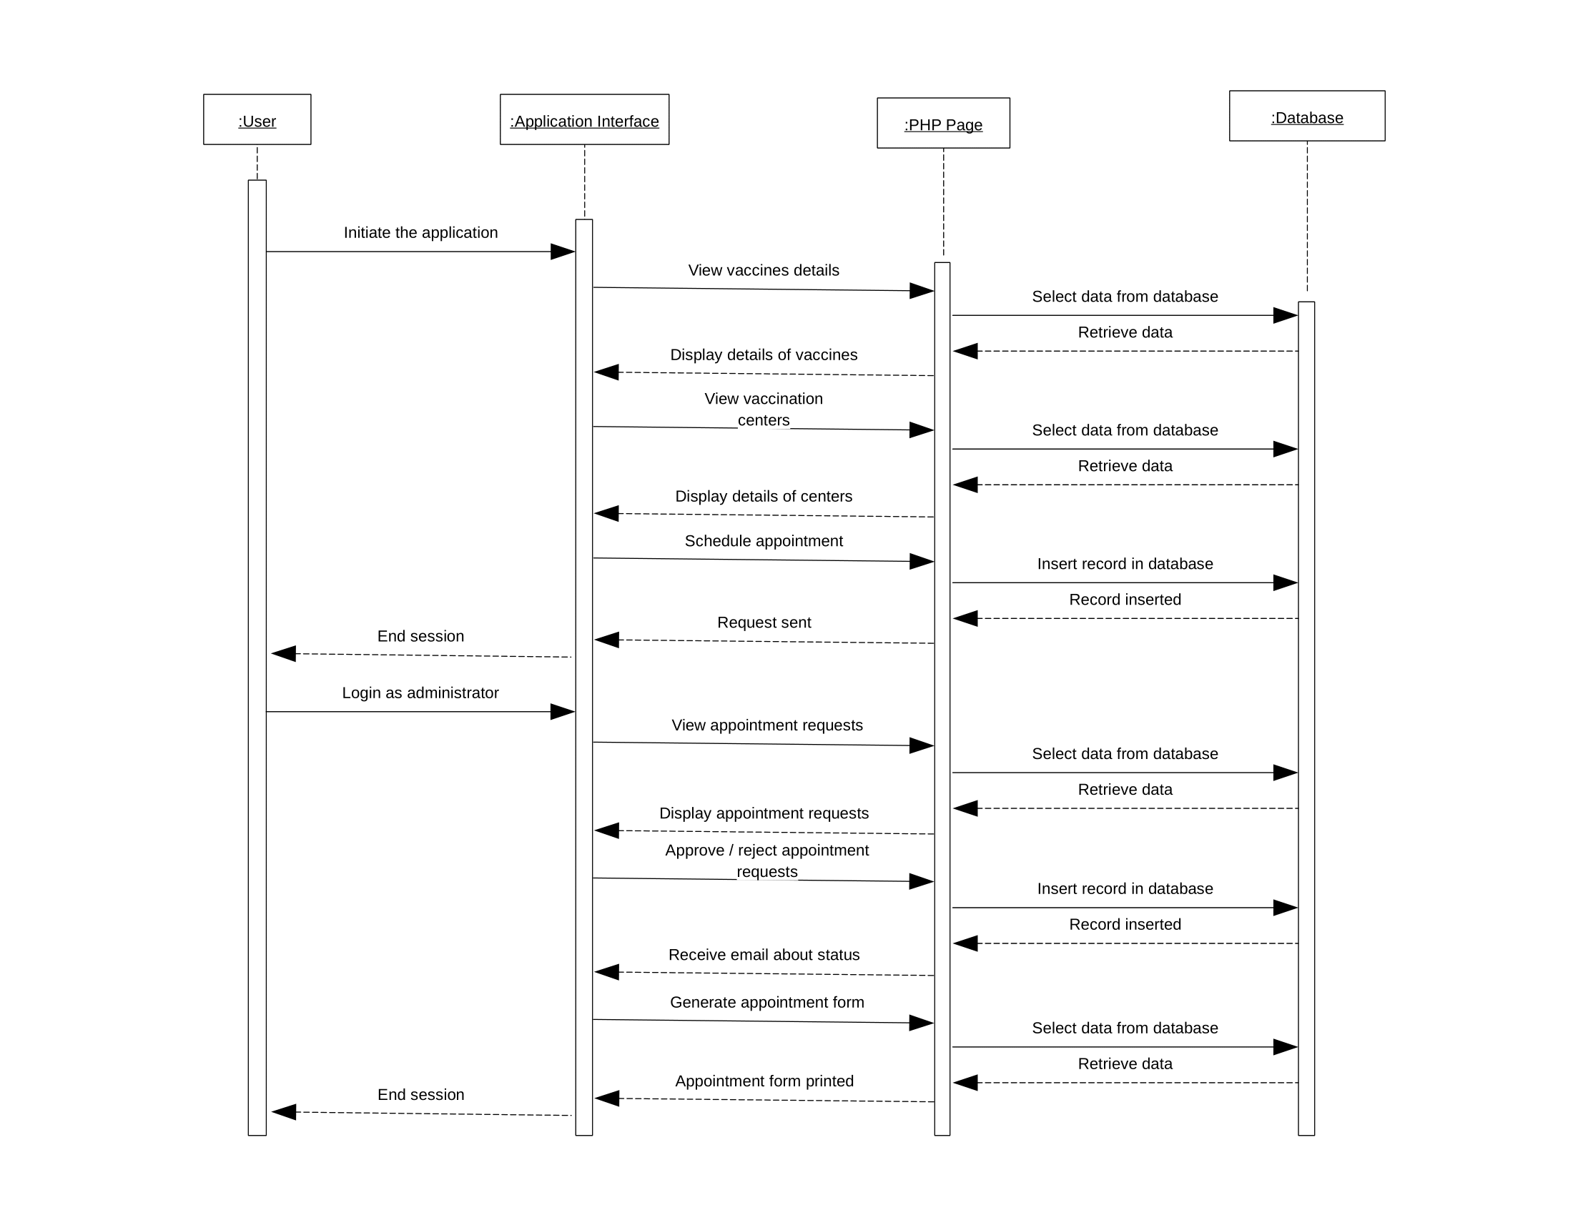

2.7 Object Model/Logical Model (Class Diagram)
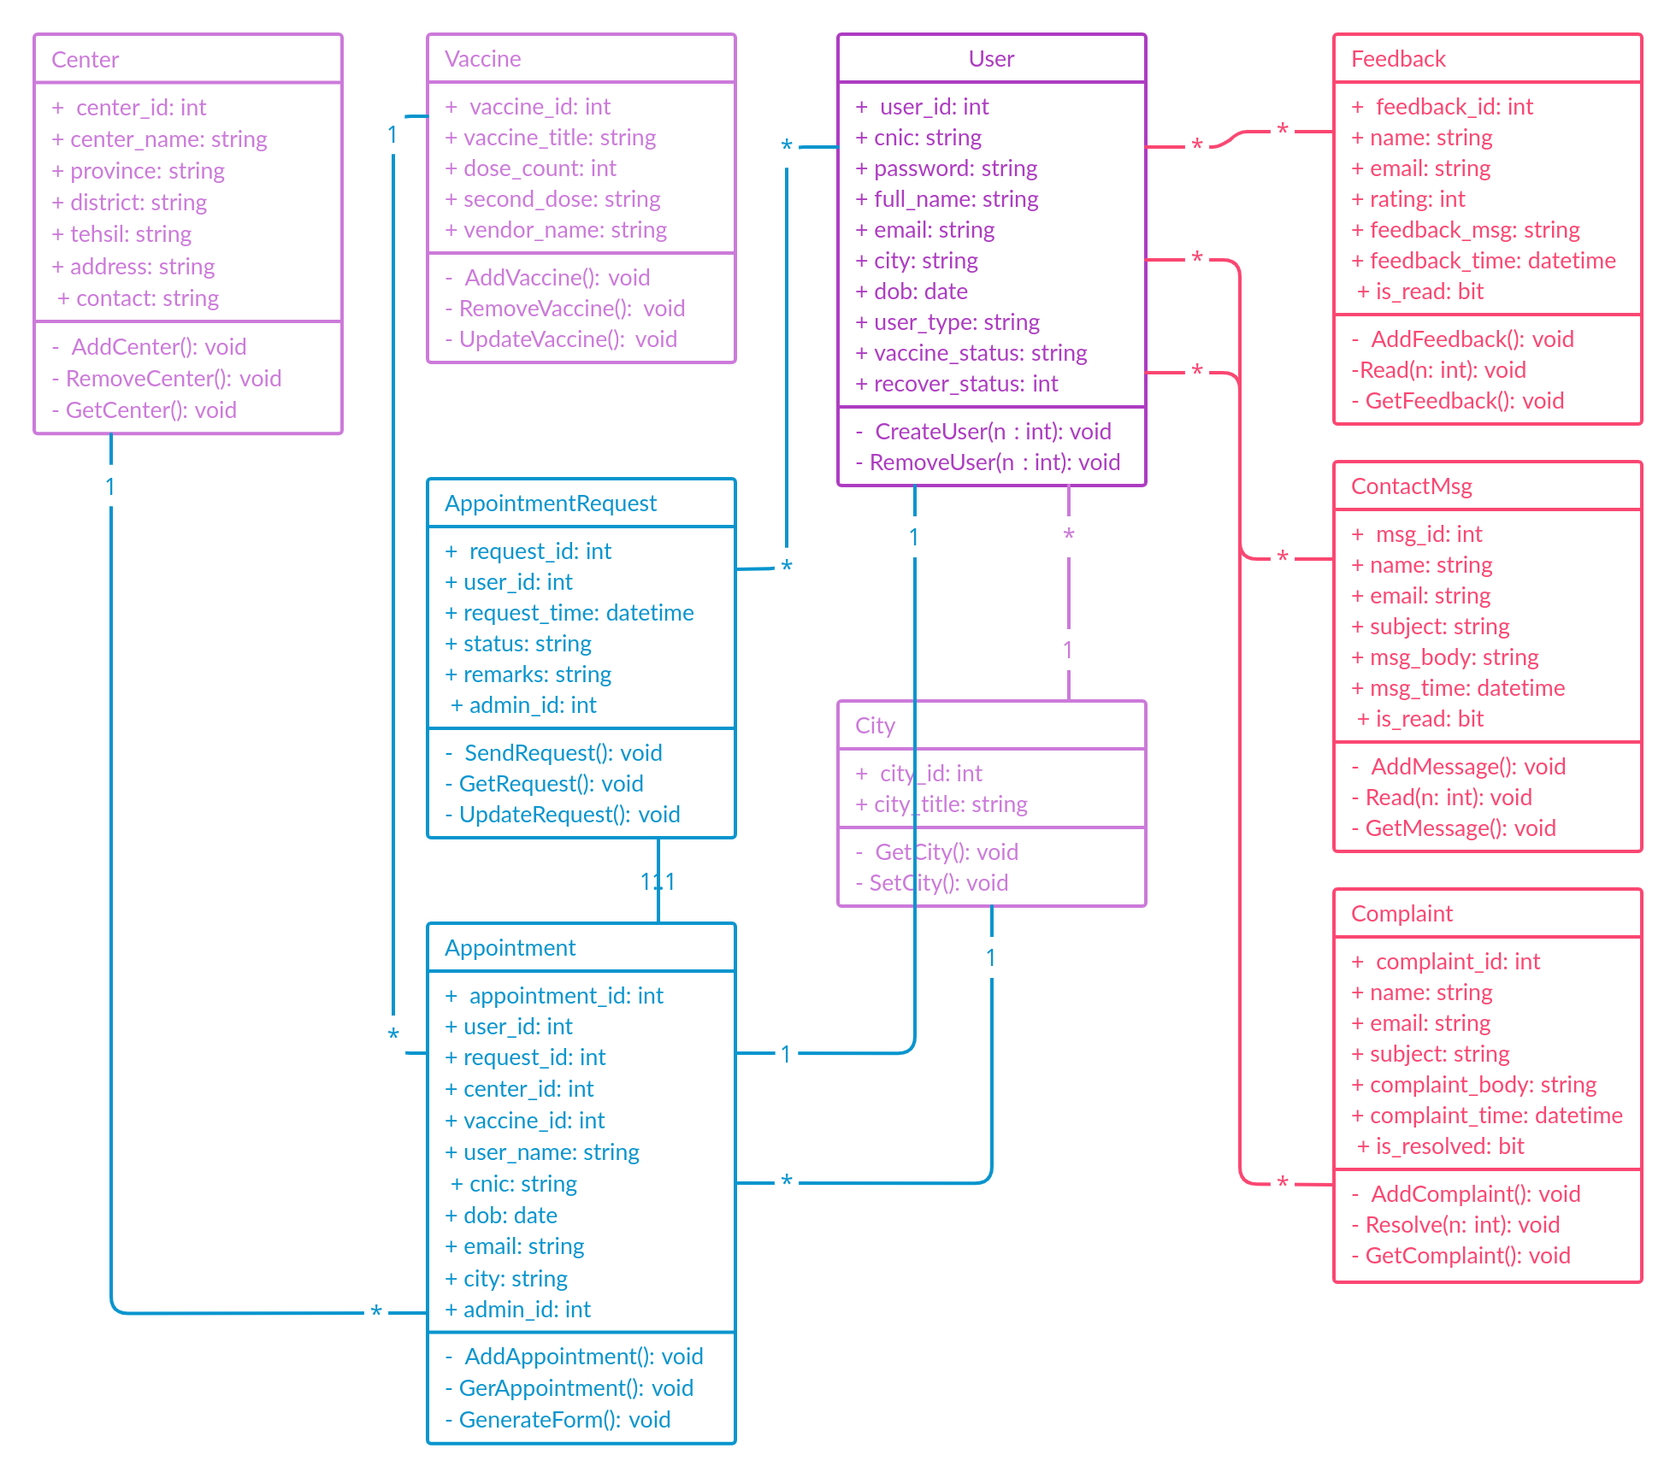

2.8 Database Model (Database Diagram)
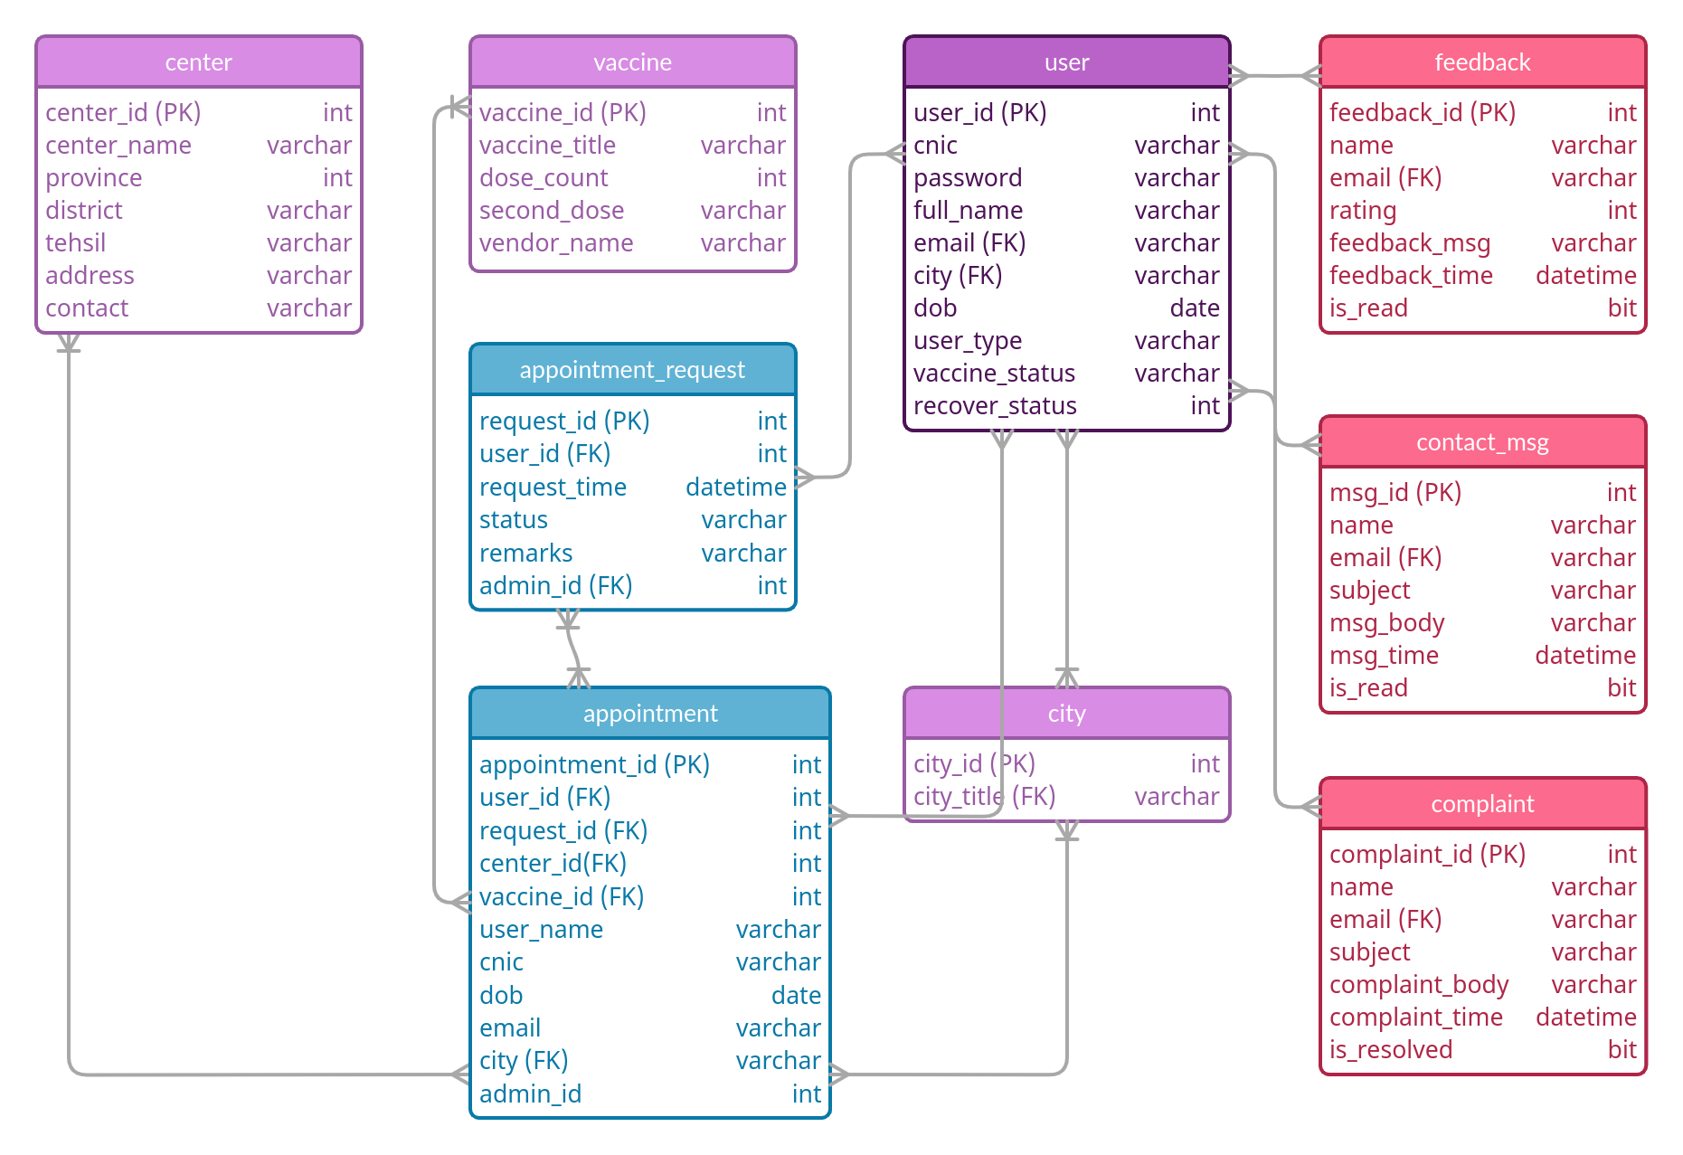

2.9 Graphical User Interfaces

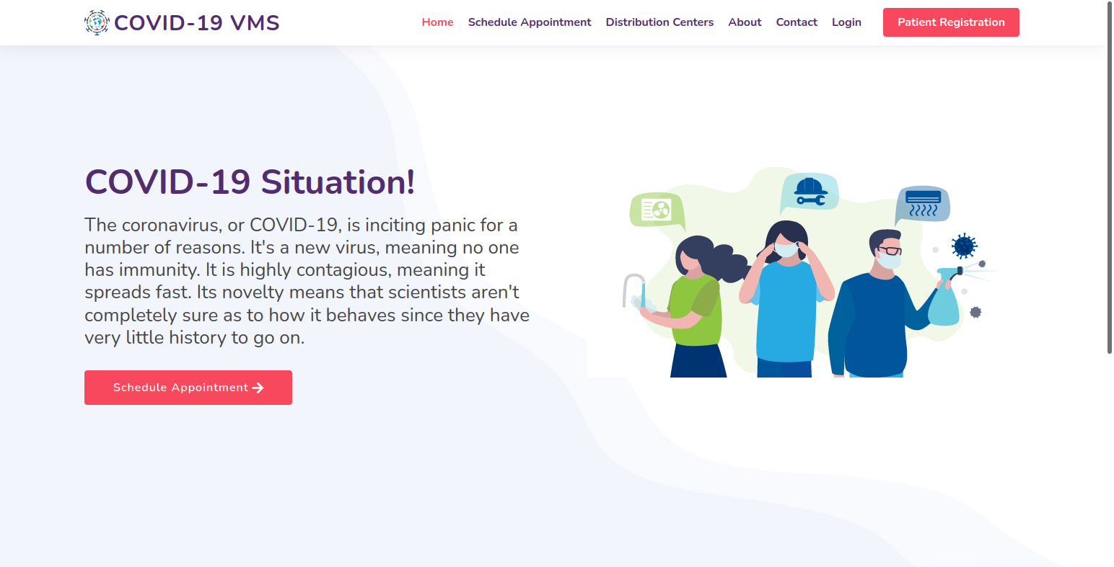
Figure 1: Home

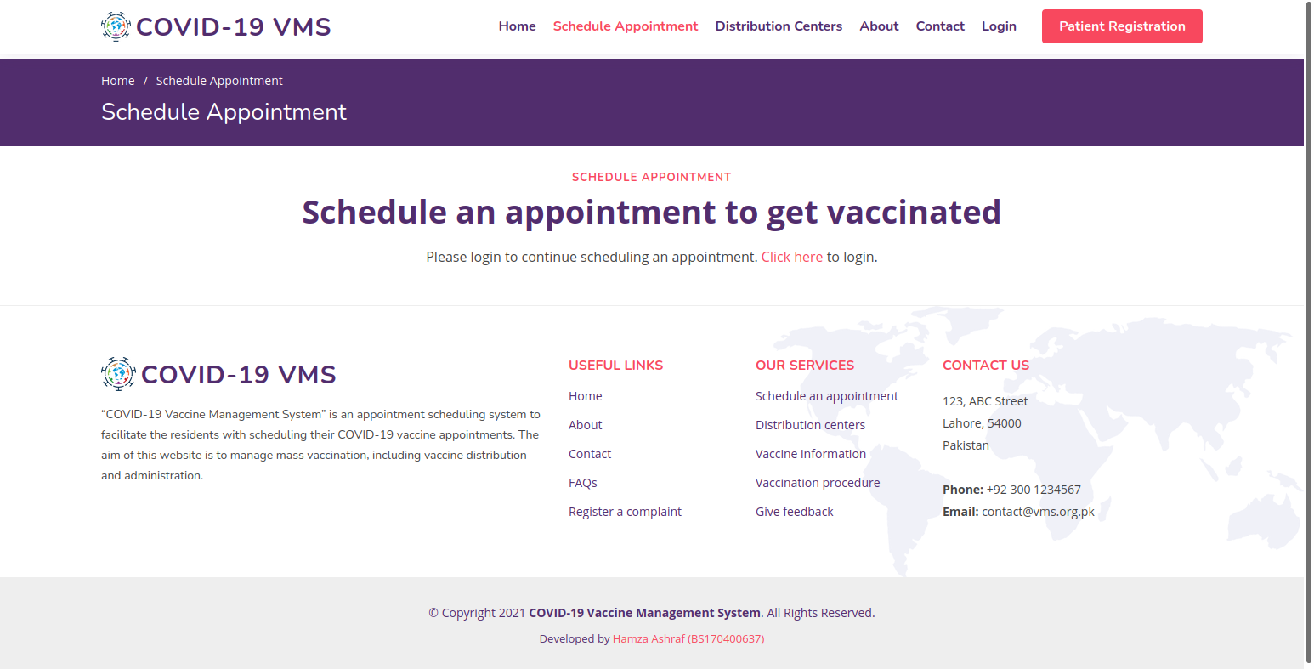
Figure 2: Schedule Appointment

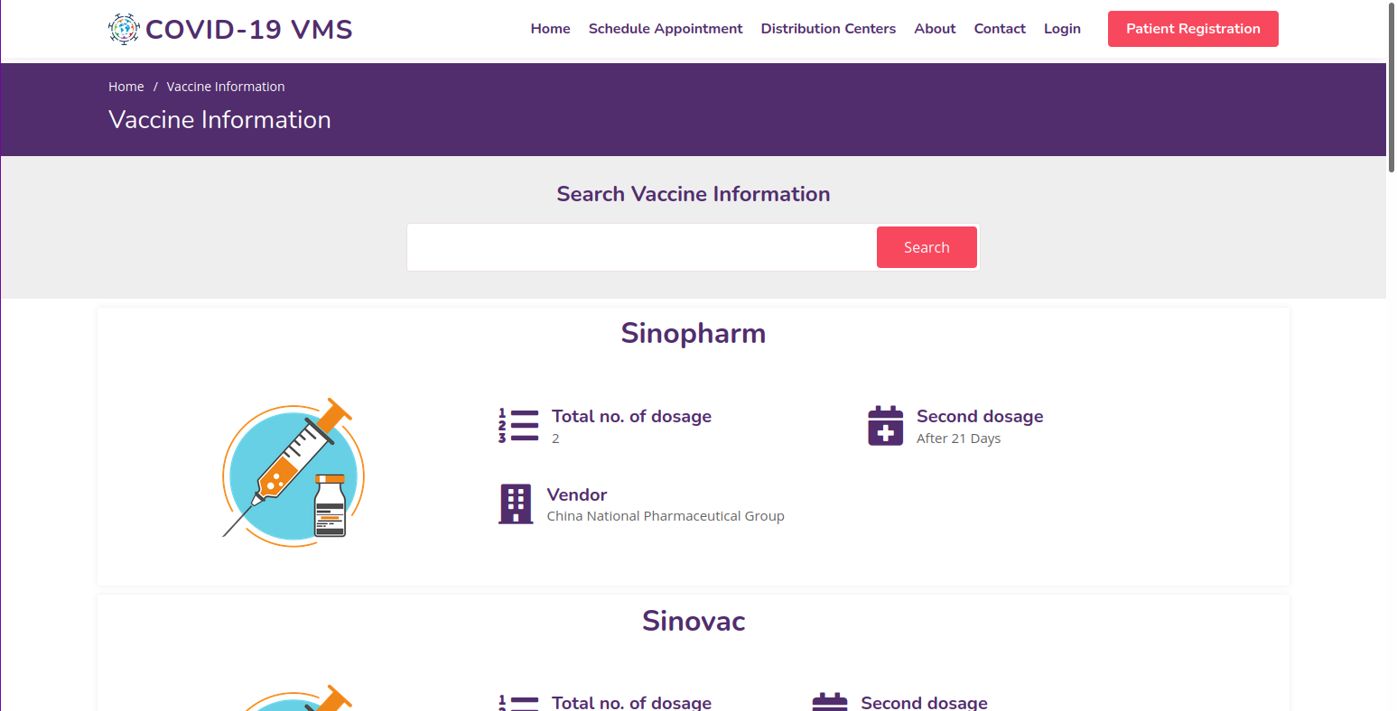
Figure 3: View Vaccination Details

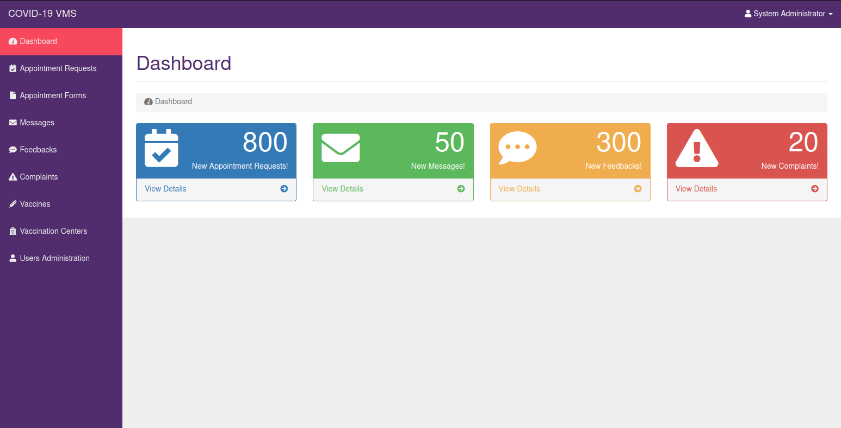
Figure 4: Admin Dashboard

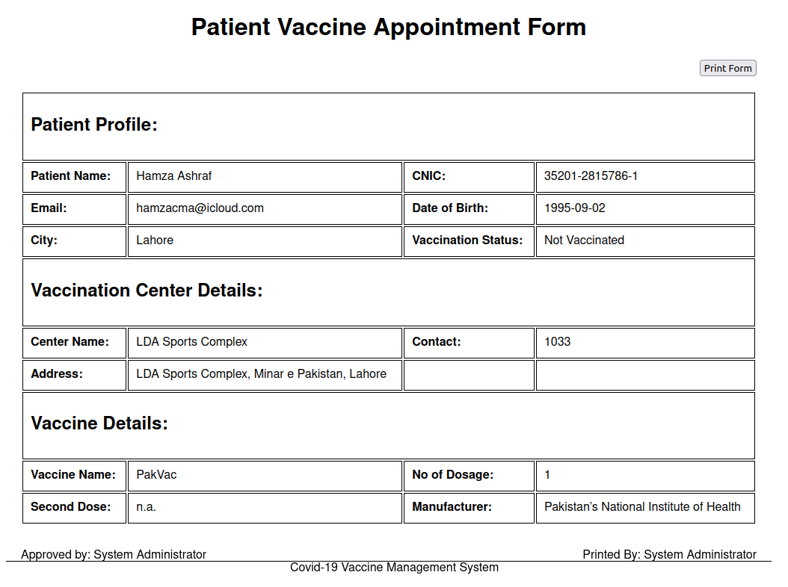
Figure 5: Print Appointment Form

CHAPTER 3
Development

3.1 Development Plan (Architecture Diagram)
REFERENCES

- www.w3schools.com
- www.creately.com
- dev.mysql.com/doc/
- www.php.net/docs.php
- www.openproject.org
- www.libreoffice.org
- www.ubuntu.com
- www.apache.org
- www.getbootstrap.com
- fonts.google.com
- www.fontawesome.com
- www.atom.io
- www.mozilla.org/en-US/firefox/new/

APPENDIX

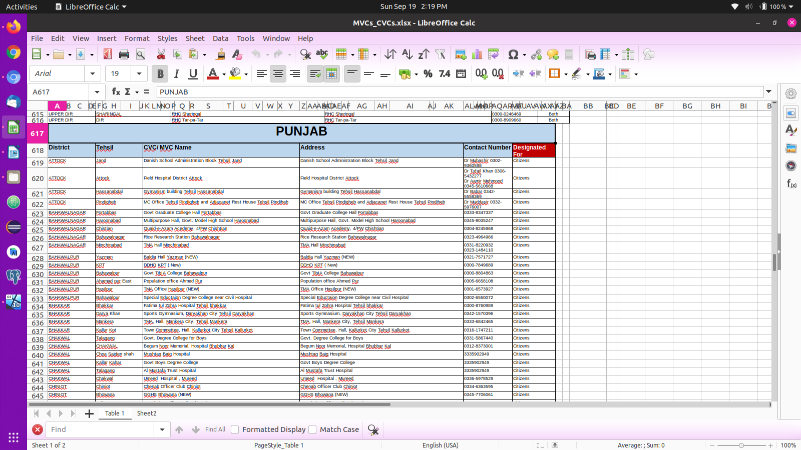
Figure 6: Vaccination Centers Raw Data

